**Project 5 –** **2004 20x4 LCD Display**

Sketch displays a corporate name, product line info and a phone number, followed by price information for the seller’s inventory. It uses a 2004A LCD display with attached I2C module.

This program also has a function, writeLine(int, String), which writes a line of text one character at a time using the lcd.print() function on line 0, 1, 2, or 3 of the display. This function expects either 0, 1, 2 or 3 for the first argument, the line number to write, and a 20-character text string for the second argument. The function does not error check for string length.

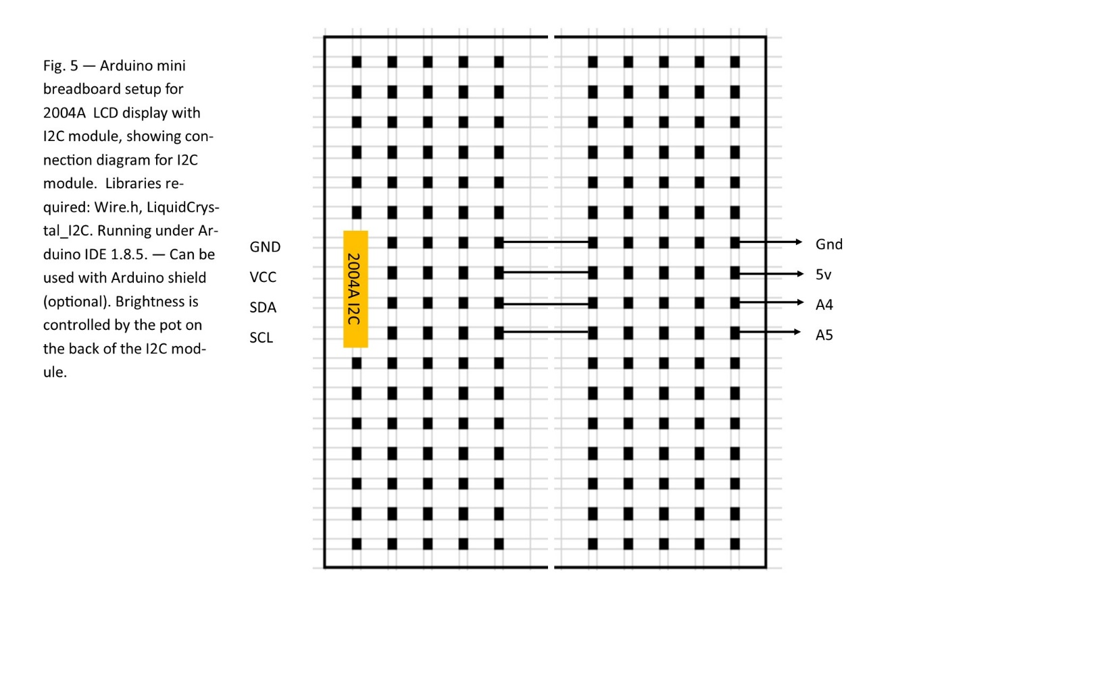

**Code for 2004 20x4 LCD Display**

#include <Wire.h>

#include <LiquidCrystal_I2C.h>

// connections

// 2004 UNO

// ---- ---

// GND Gnd

// VCC 5v

// SDA A4

// SCL A5

// Set the LCD address to 0x27 for a 20 chars and 4 line display

LiquidCrystal_I2C lcd(0x27, 20, 4);

int timer=5000;

// user function to write a string (linetext) to line (linenum) of the display

// Function expects a 20 character string. No error checking is performed.

void writeLine(int linenum, String linetext)

{

lcd.setCursor(0,linenum); // go to column 0 of line (linenum)

lcd.print(linetext); // write all 20 characters of line

}

void setup()

{

// initialize the LCD

lcd.begin();

lcd.clear();

lcd.backlight();

delay(100);

}

void loop()

{

lcd.clear();

writeLine(0,"ExoticAroma Products"); // this is line 0

writeLine(1,"Waxes, Lamps, & more"); // this is line 1

writeLine(2," Establsihed 2013 "); // this is line 2

writeLine(3," 773-377-5504 "); // this is line 3

delay(timer);

lcd.clear();

writeLine(0,"ExoticAroma Products"); // this is line 0

writeLine(1,"Small Wax.....$ 3.00"); // this is line 1

writeLine(2,"Medium Wax....$ 7.00"); // this is line 2

writeLine(3,"Large Wax.....$ 9.00"); // this is line 3

delay(timer);

lcd.clear();

writeLine(0,"ExoticAroma Products"); // this is line 0

writeLine(1,"Small Lamps...$14-up"); // this is line 1

writeLine(2,"Large Lamps...$30-up"); // this is line 2

writeLine(3,"Opportunities Avail."); // this is line 3

delay(timer);

}

**Construction of Product**

Since all pins necessary for this project are on the analog connector at the bottom of the UNO, no Shield is required for construction of dedicated model.

Since the display is a small 20-character, 4-line LCD panel, it is well suited to things such as a price display, or anything displaying information to people at distances of not more than about 18”.

Batteries should be replaced or recharged once pack reaches 7.1V.